**USER(PHP) TESTING**

* First, you need to go to the homepage of **Nature’s Fresh Mart** and then you can find the **LOGIN** button at the navigation bar.



* Then, **login form** is displayed.

Empty Login

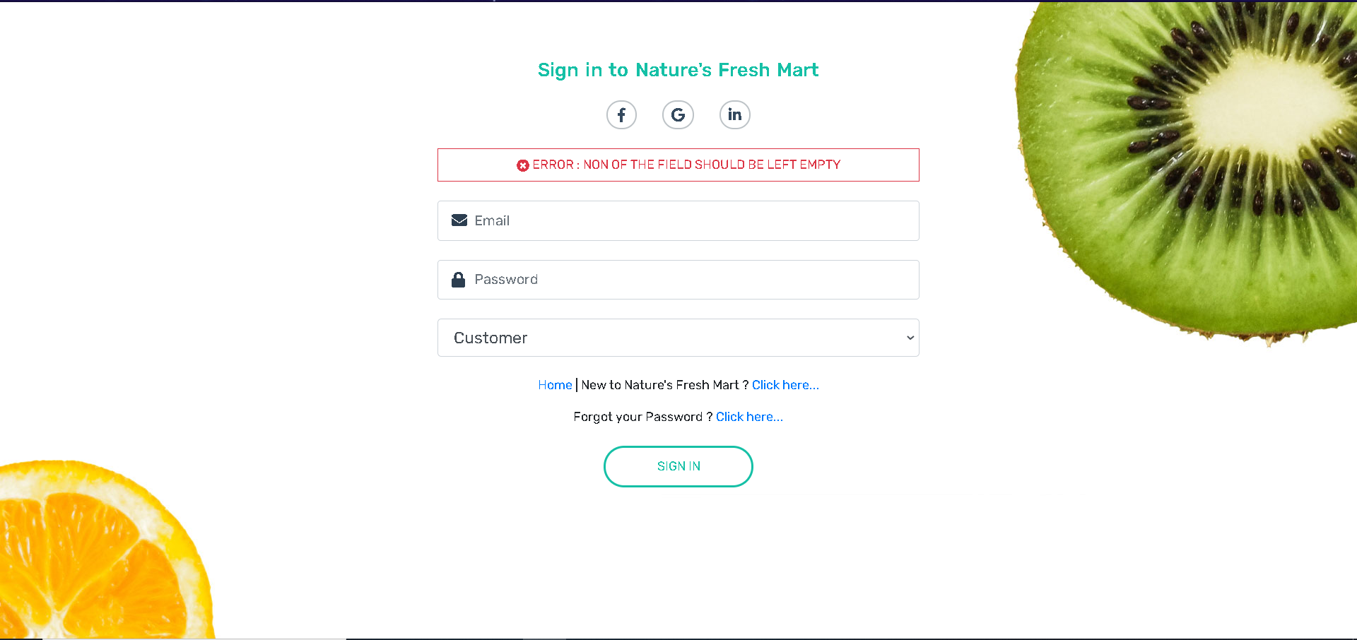

Invalid Login

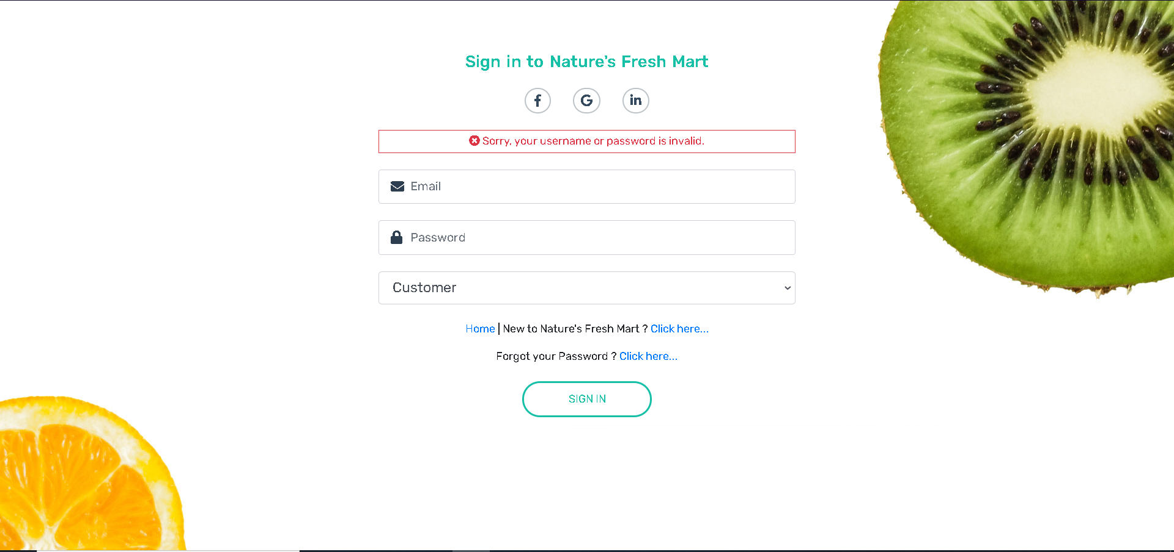

**Valid Login** Details user is redirected to homepage

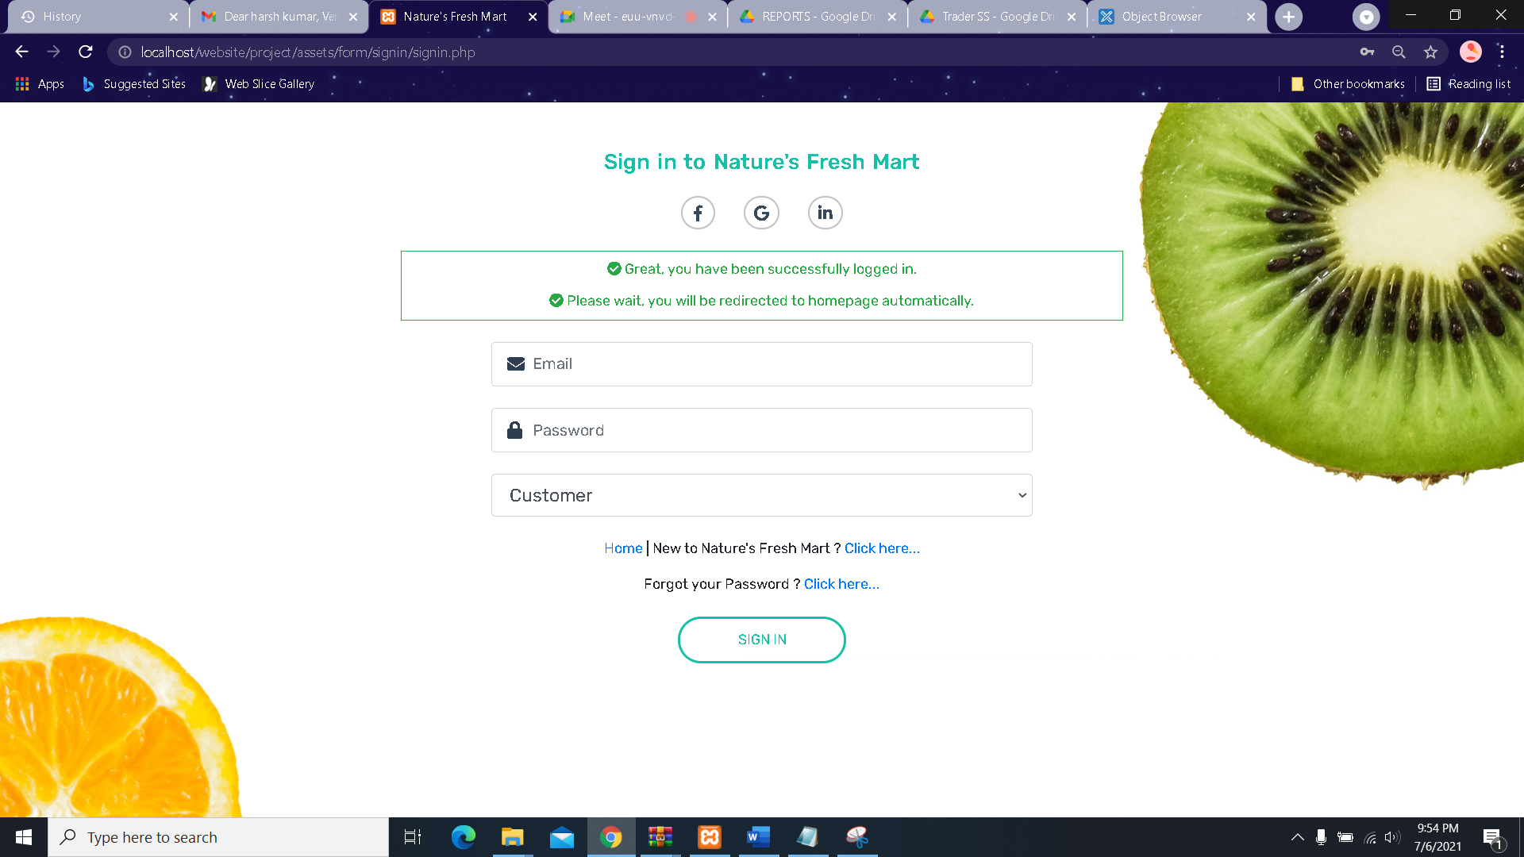

* If customer isn’t already registered then they fill up **sign-up form** which they can access directly by clicking the **Click here** link on the bottom of the login form or they can access it from the homepage.

**Sign UP with empty field**

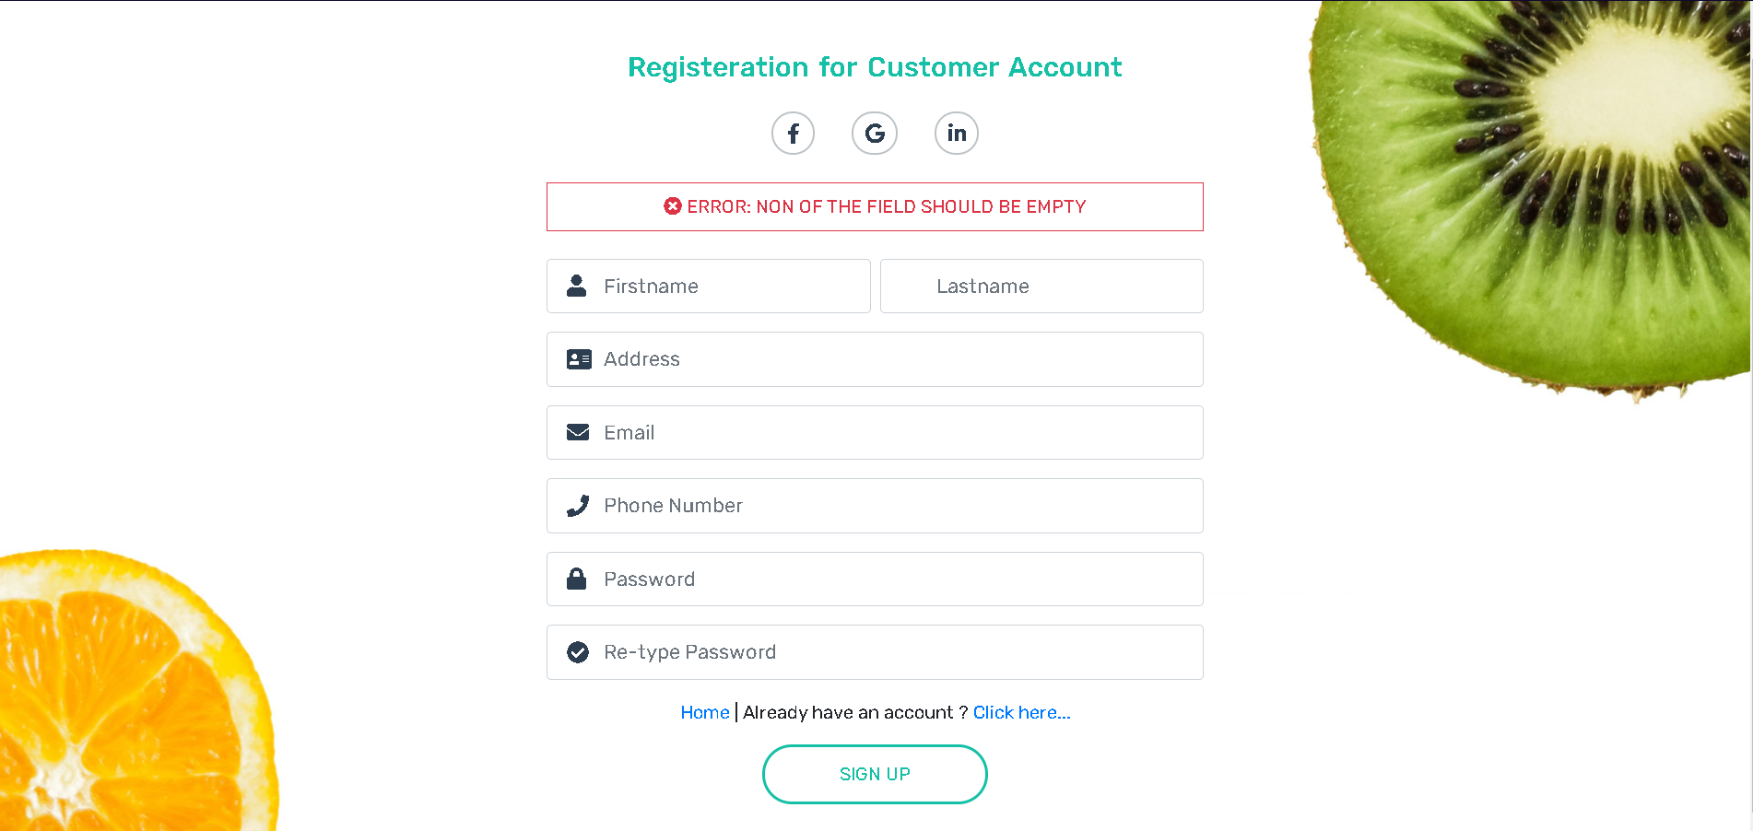

**Sign UP without validation**

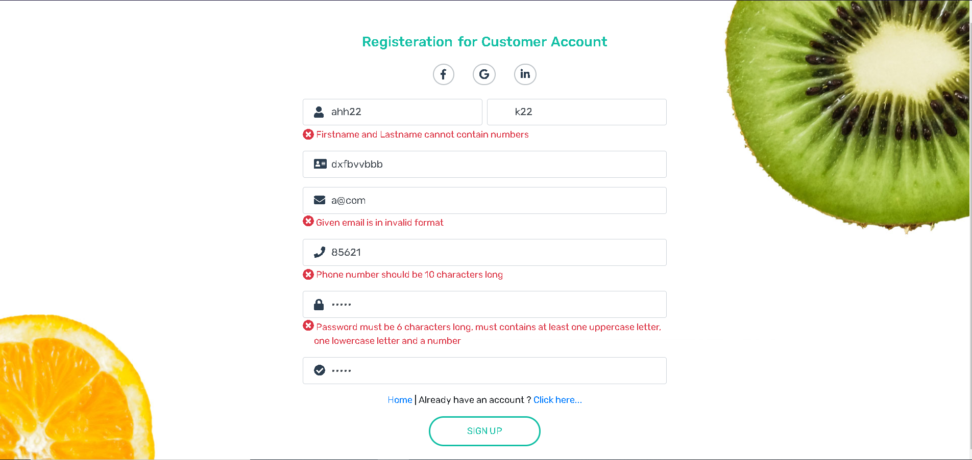

Duplicate data

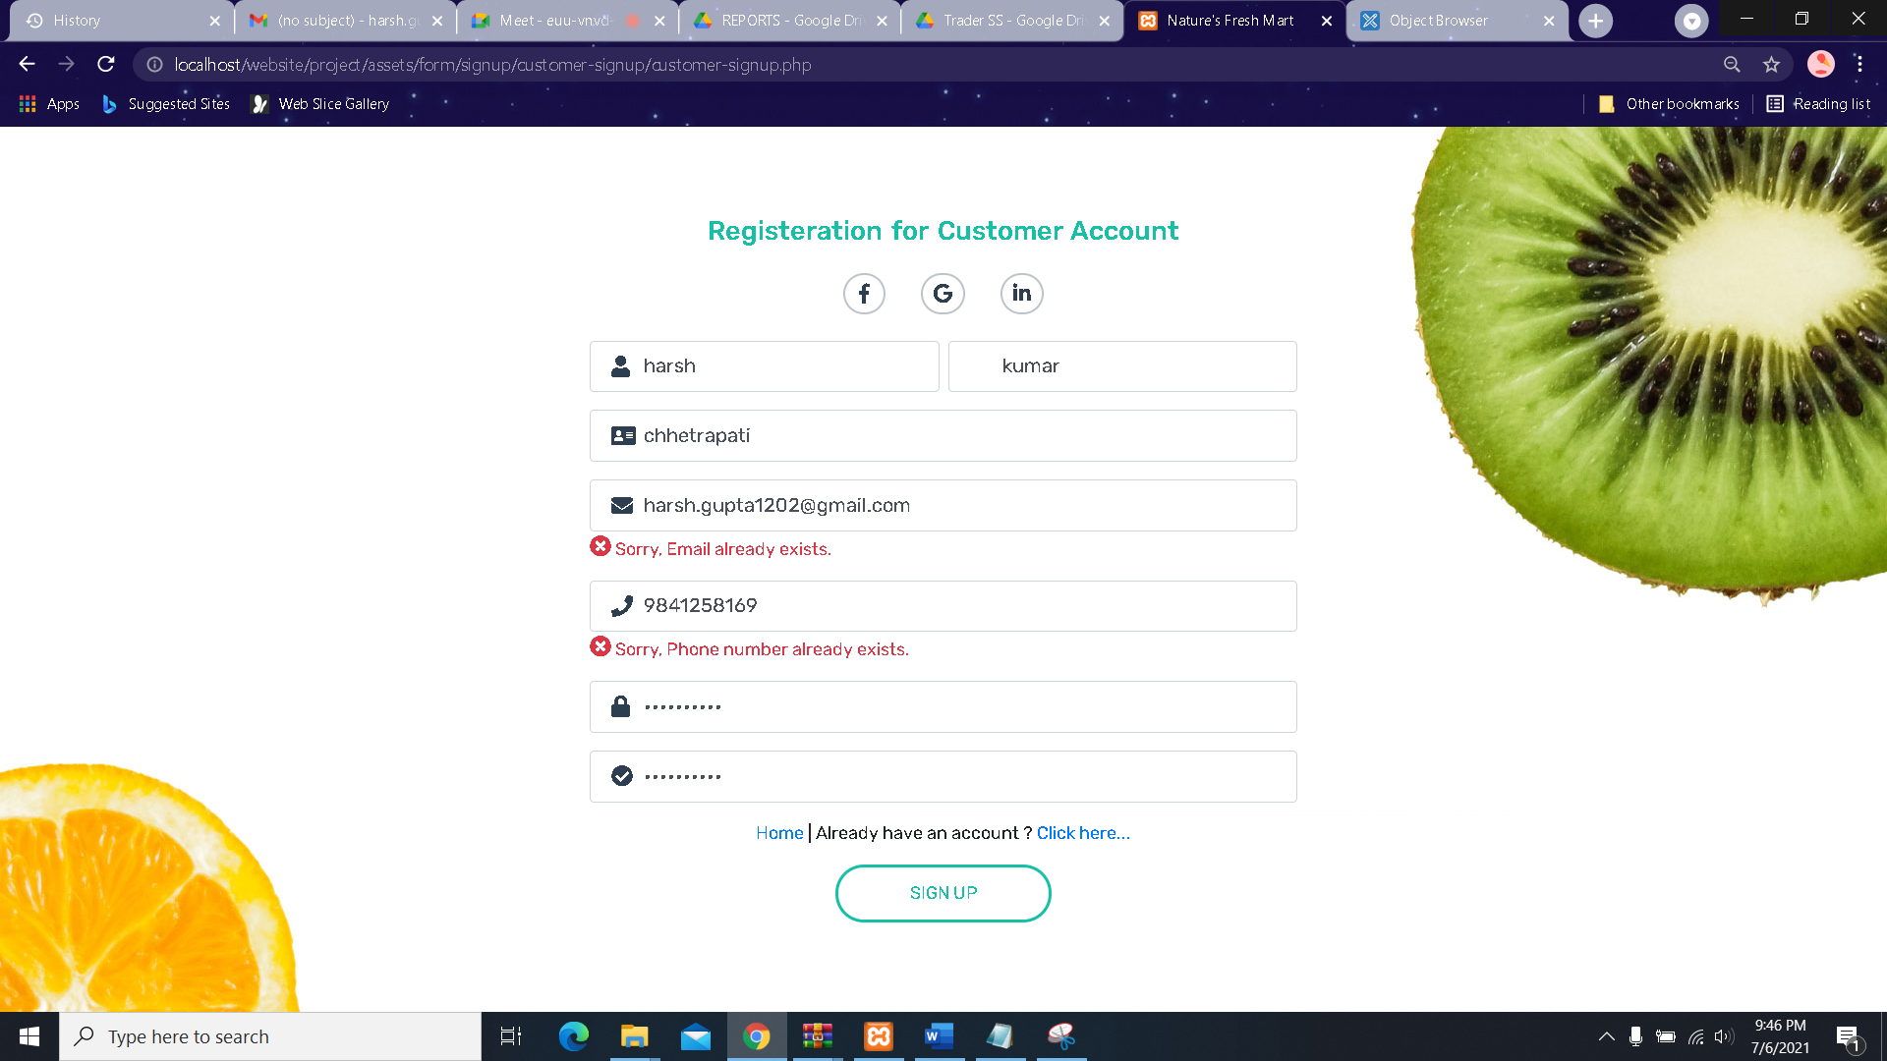

* After filling in the fields with valid information customer receives an email for verification.

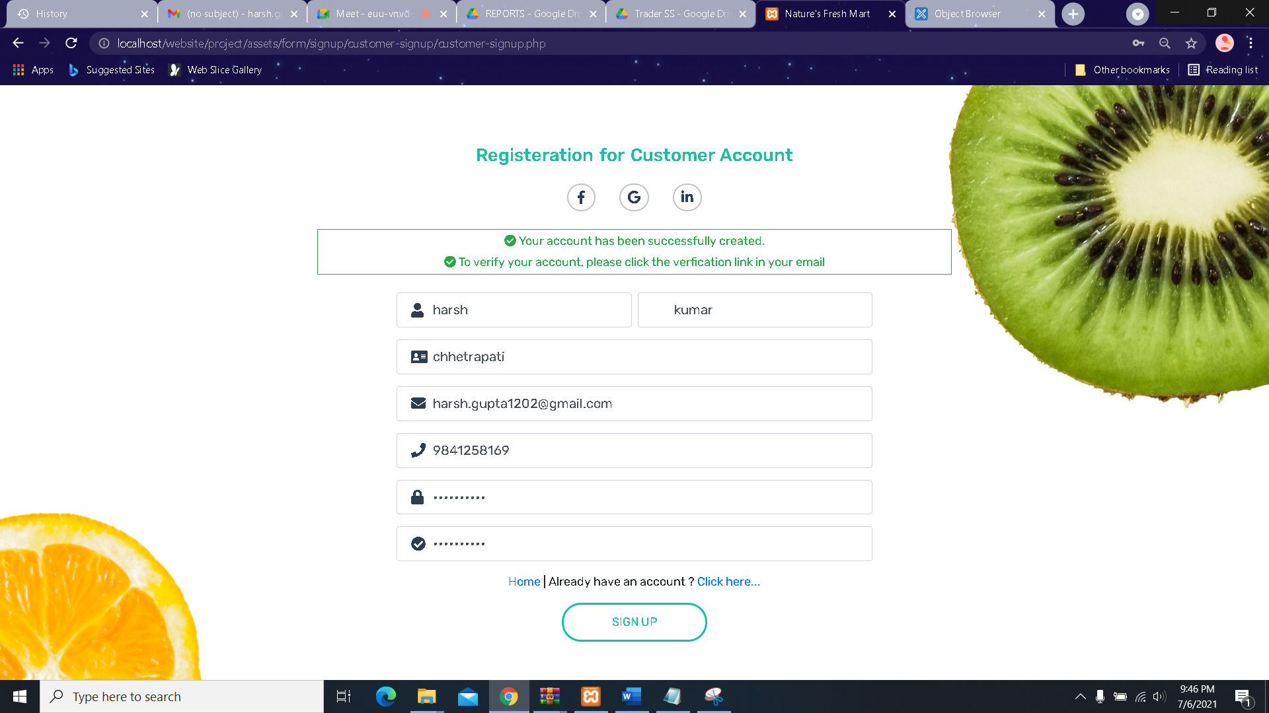

* Inside the mail, customer receives a **Verify** button which needs to be clicked after which verification is completed

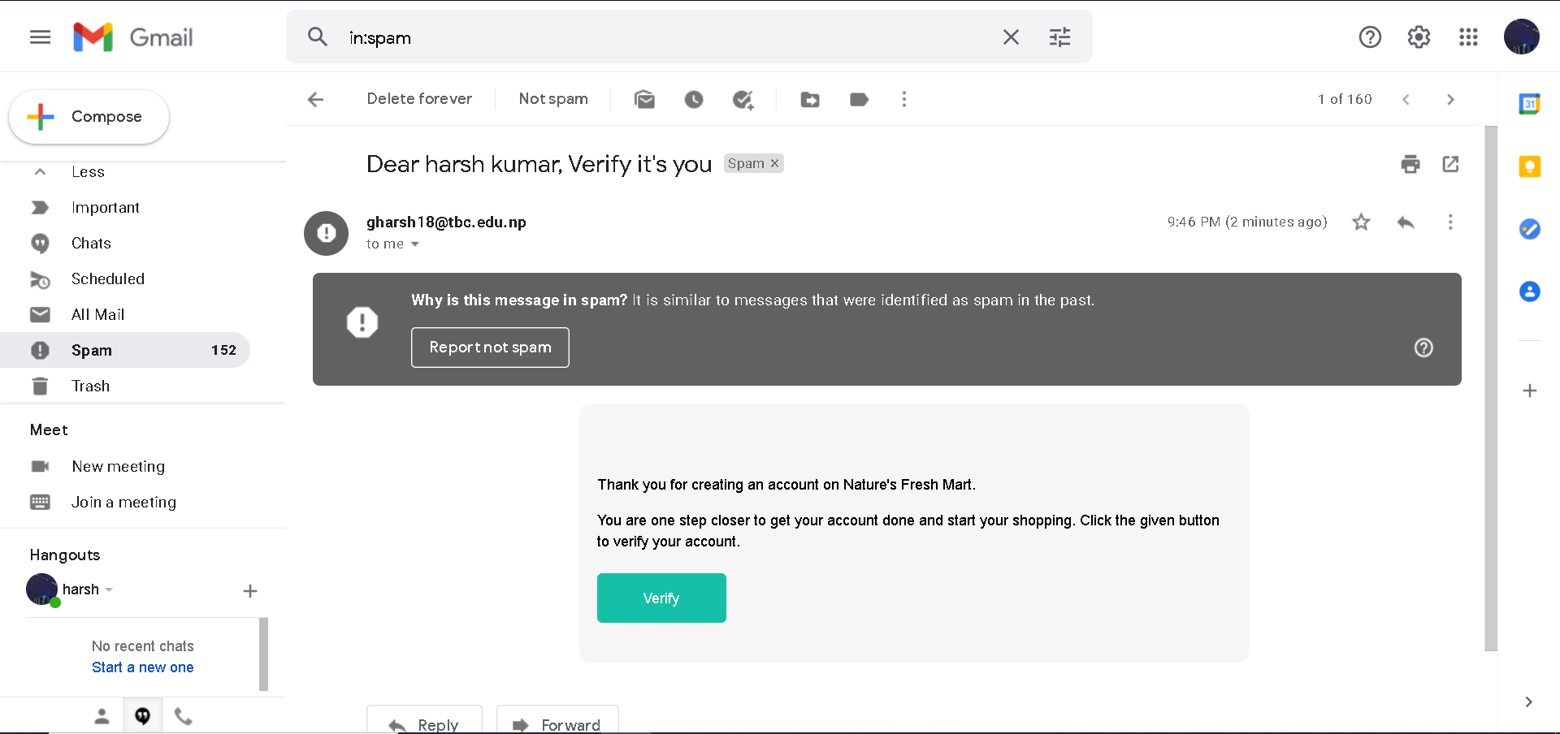



* After being verified customer logins in as a customer in this website and your homepage will look the same but with an extra option in the navbar to access the Customer Panel.

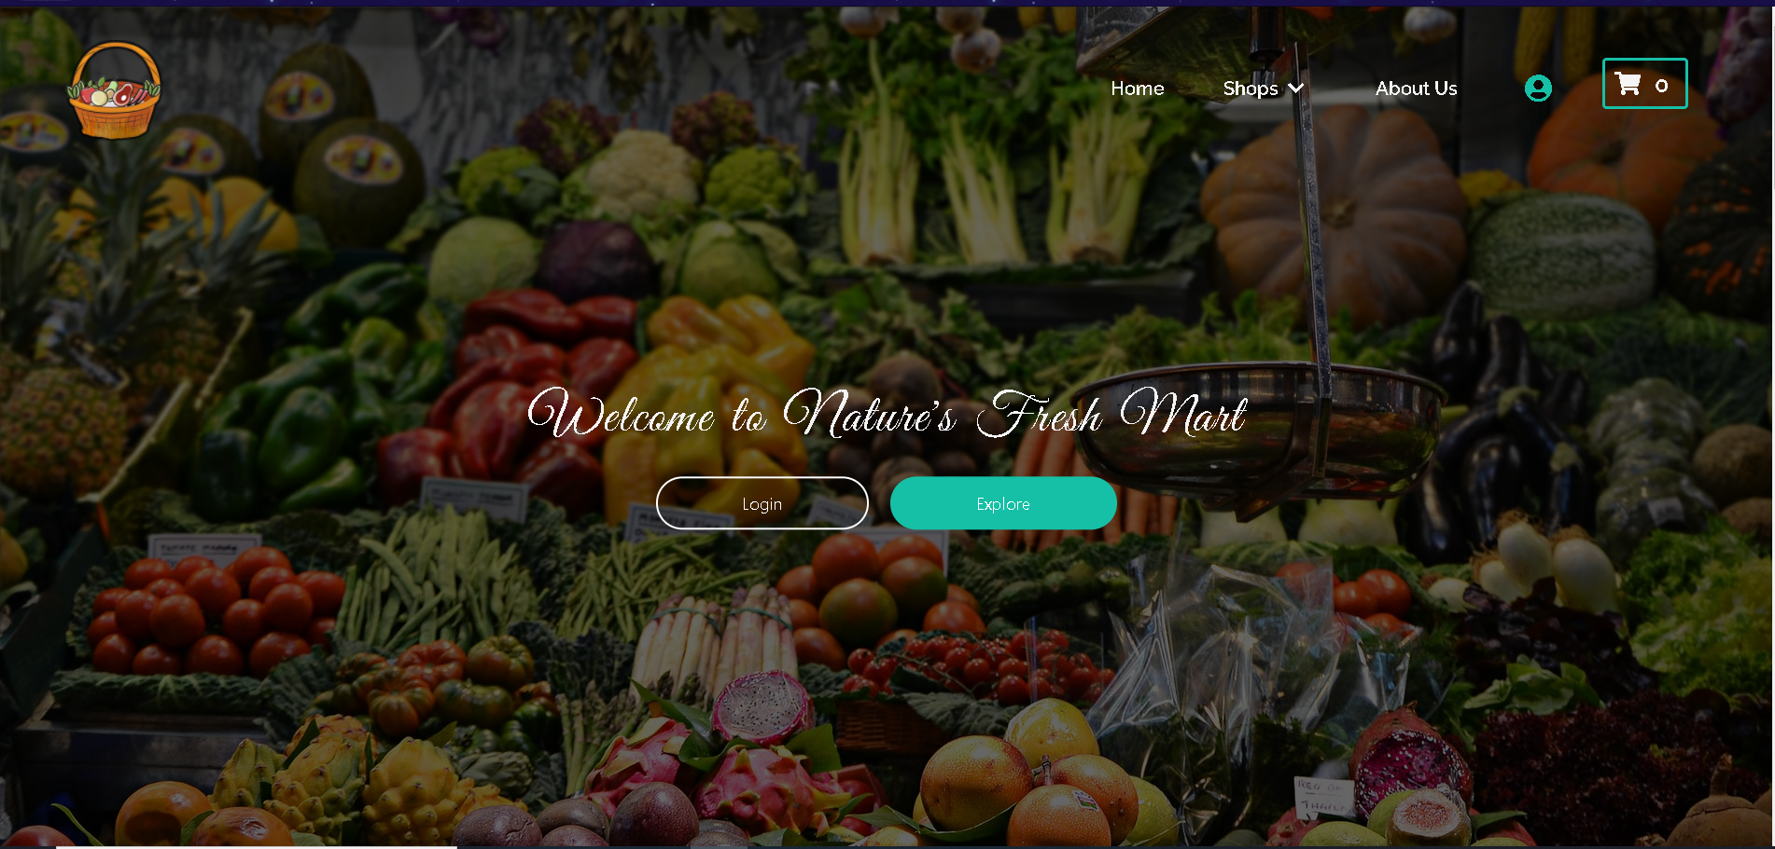

* User can also view **About Us** page

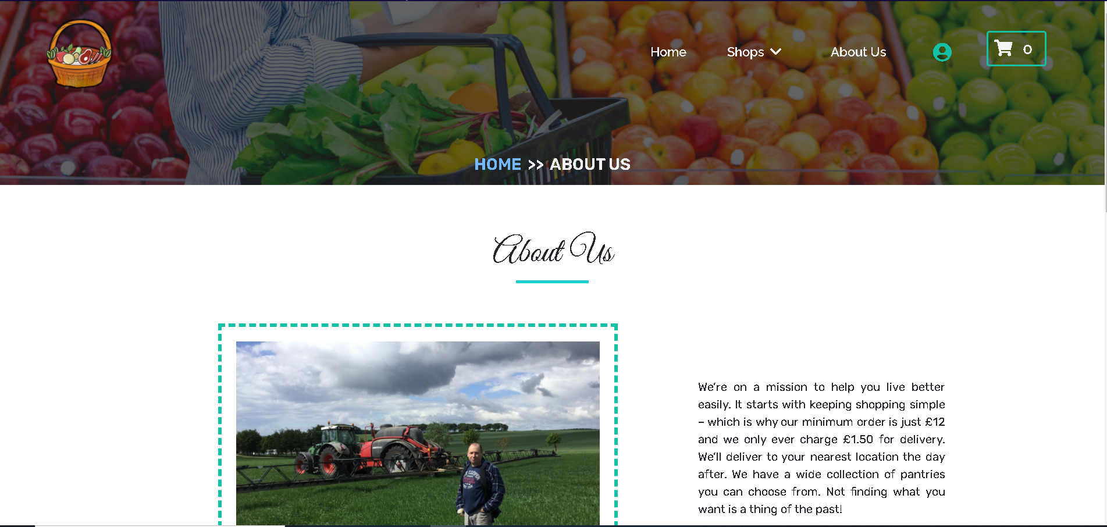

* User look at the frequently asked question by scrolling down on the homepage to **Frequently Asked Question** section.

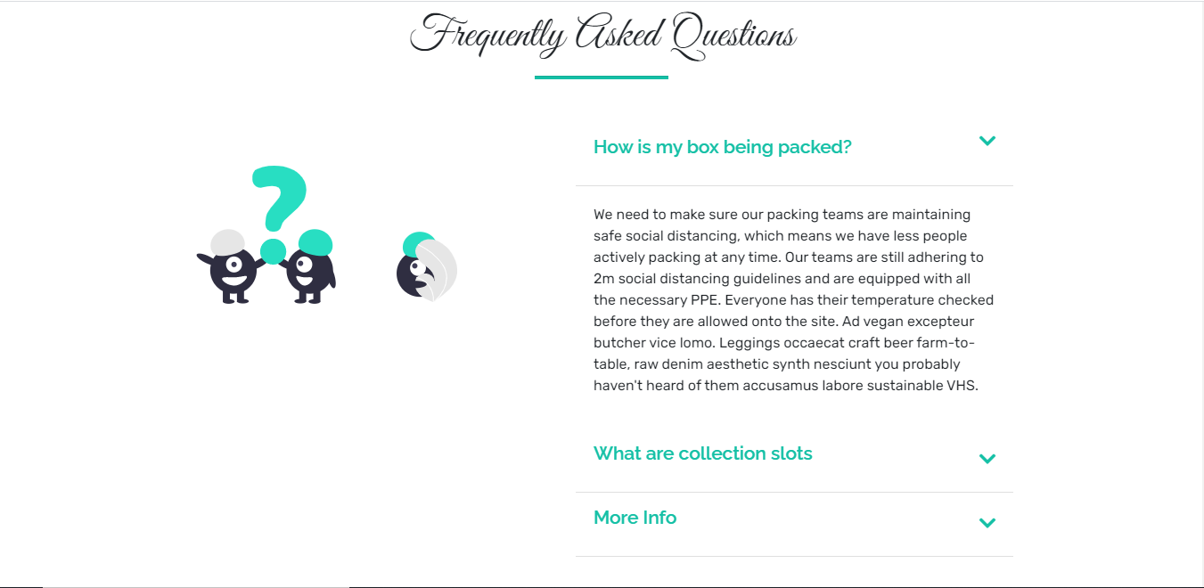

* User visits to user panel

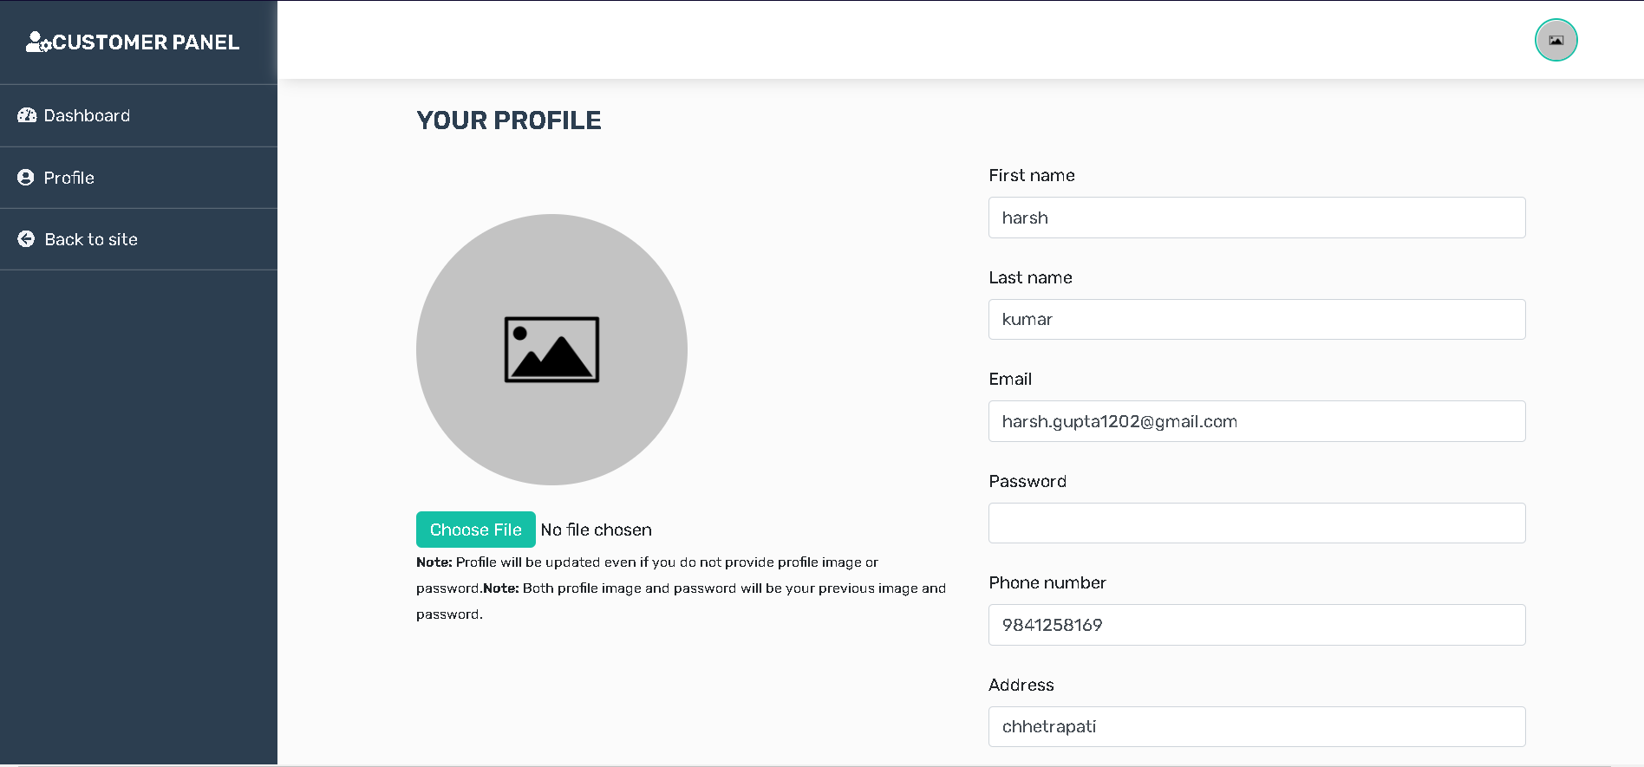

* They can update their profile

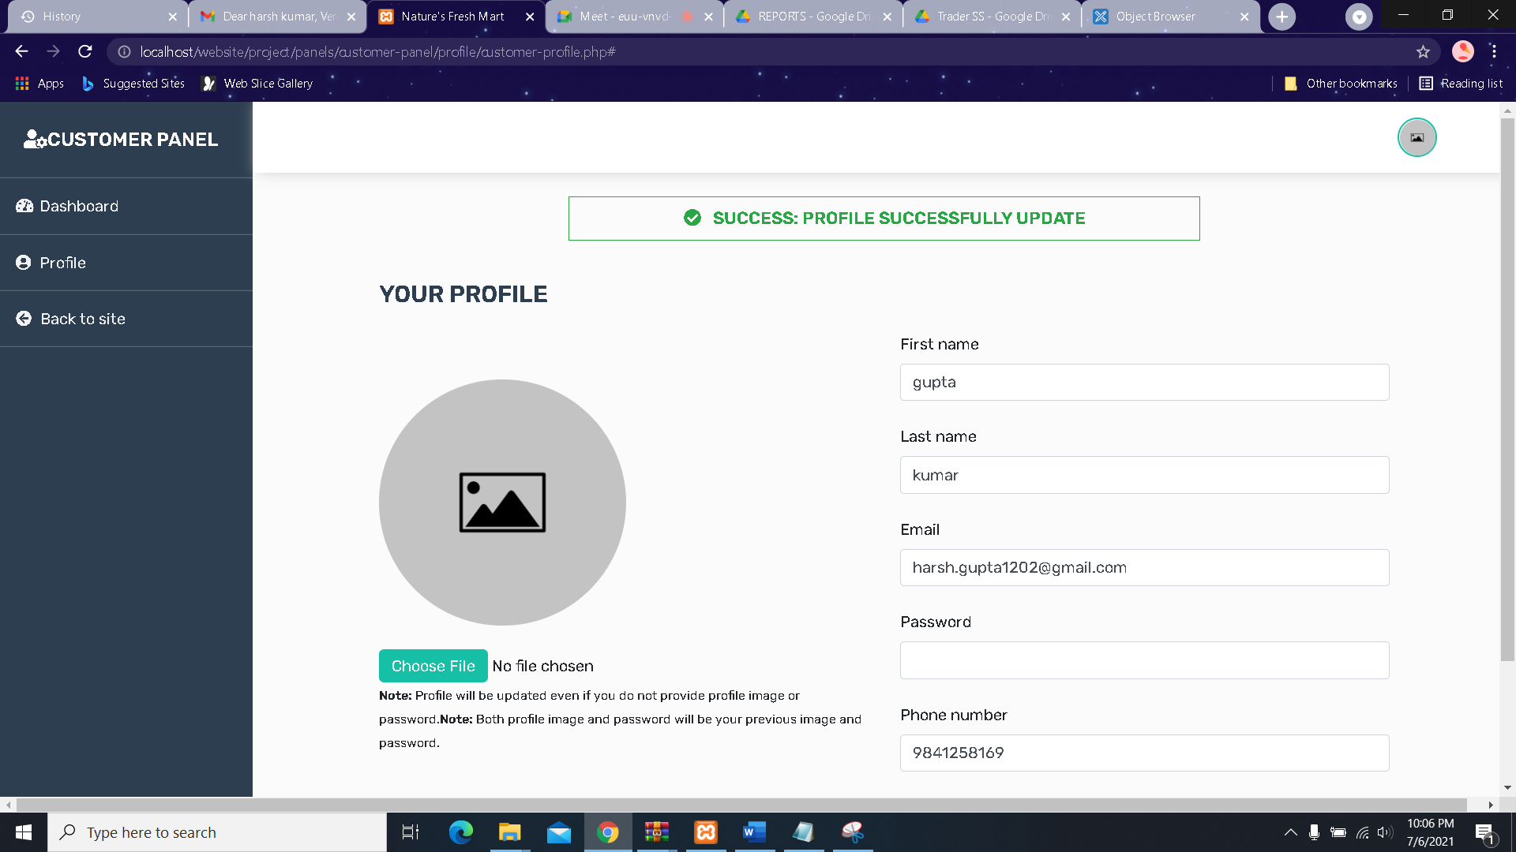

* User Dashboard where they can see the list of products ordered

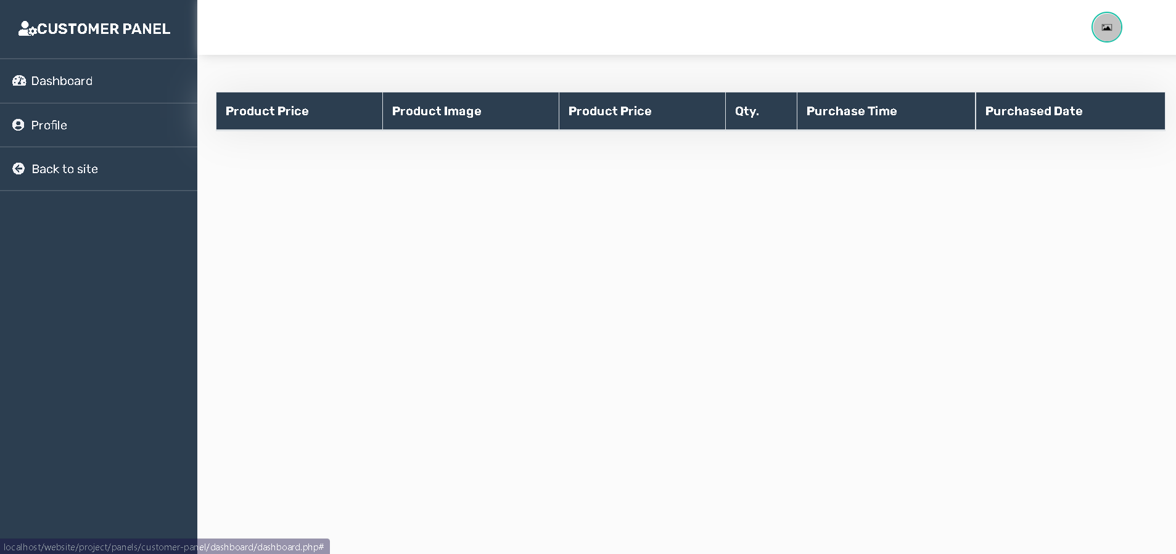

* Customer can go to individual shop page from navigation bar (Shops) for shopping

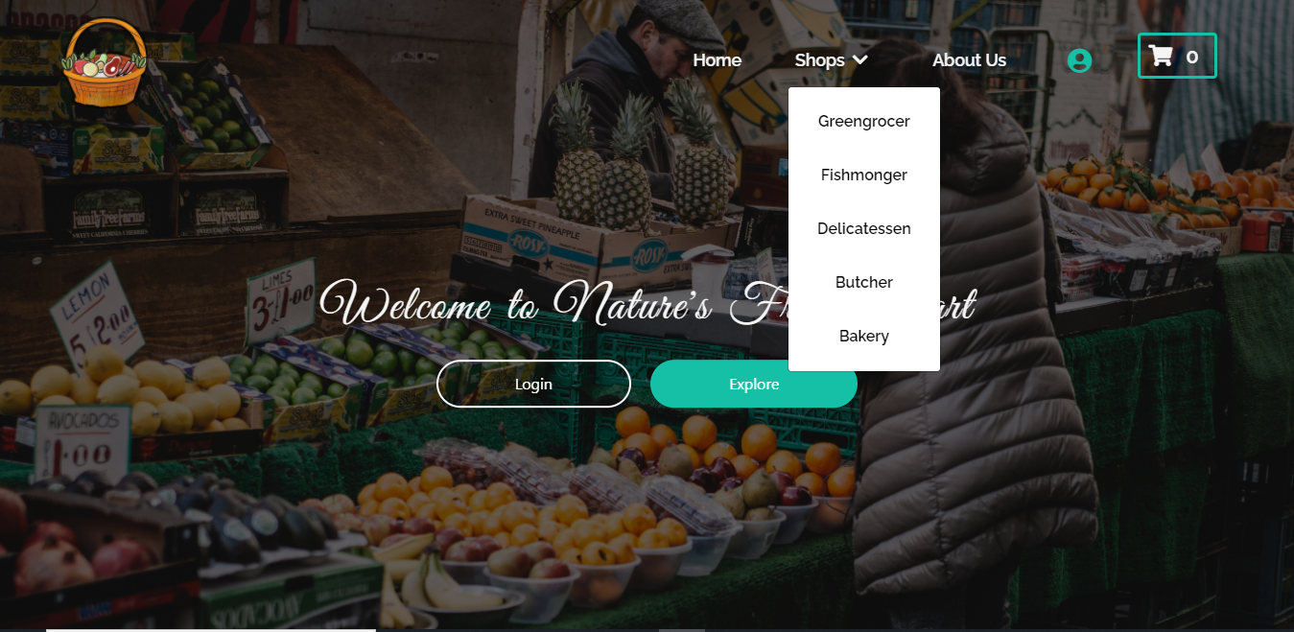

* Individual Shop Page for Registered Customer

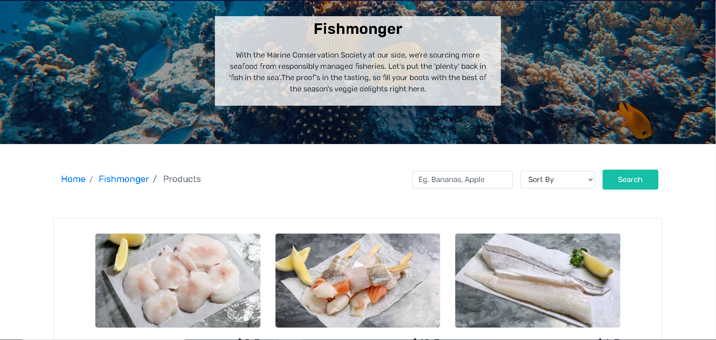

* Sorting the products

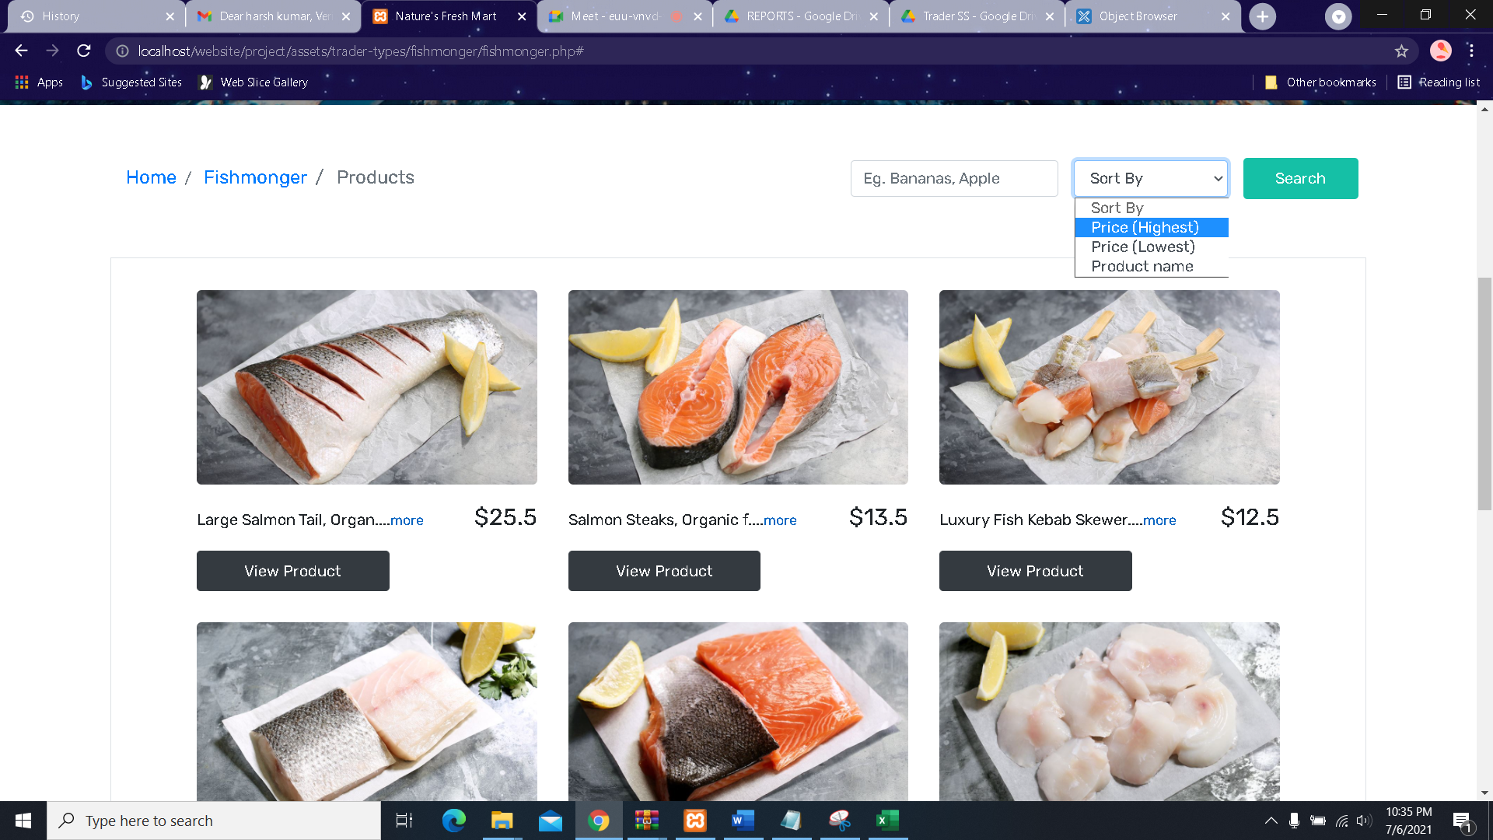

* Searching the products

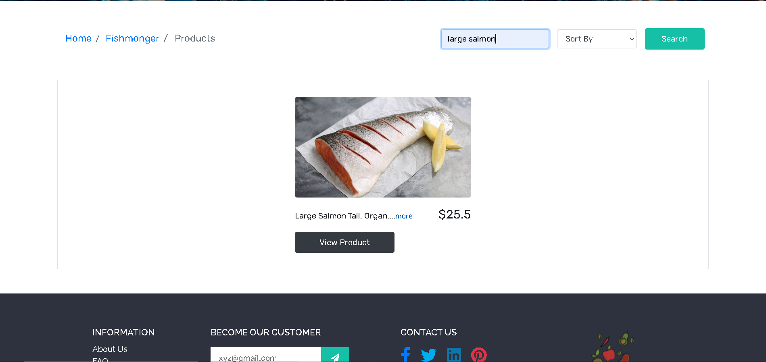

* If Registered customer wants to view products details

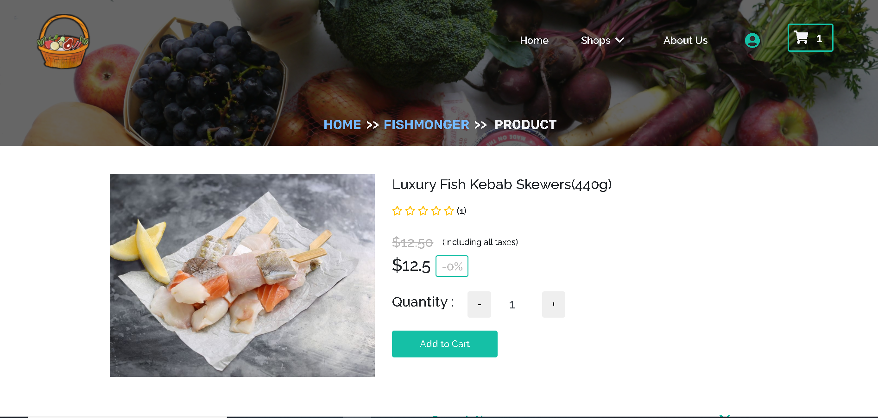

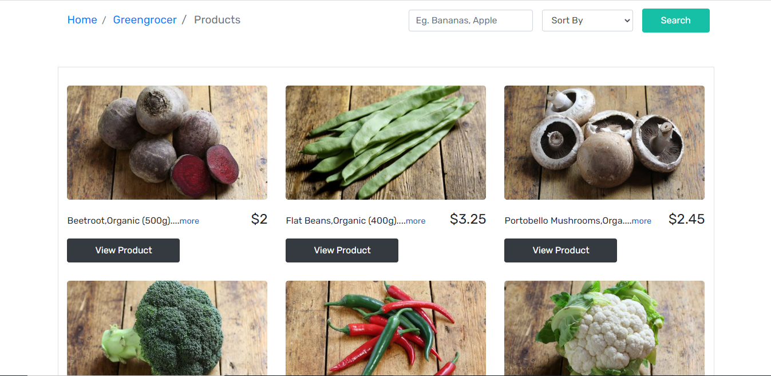

Inside cart after adding product

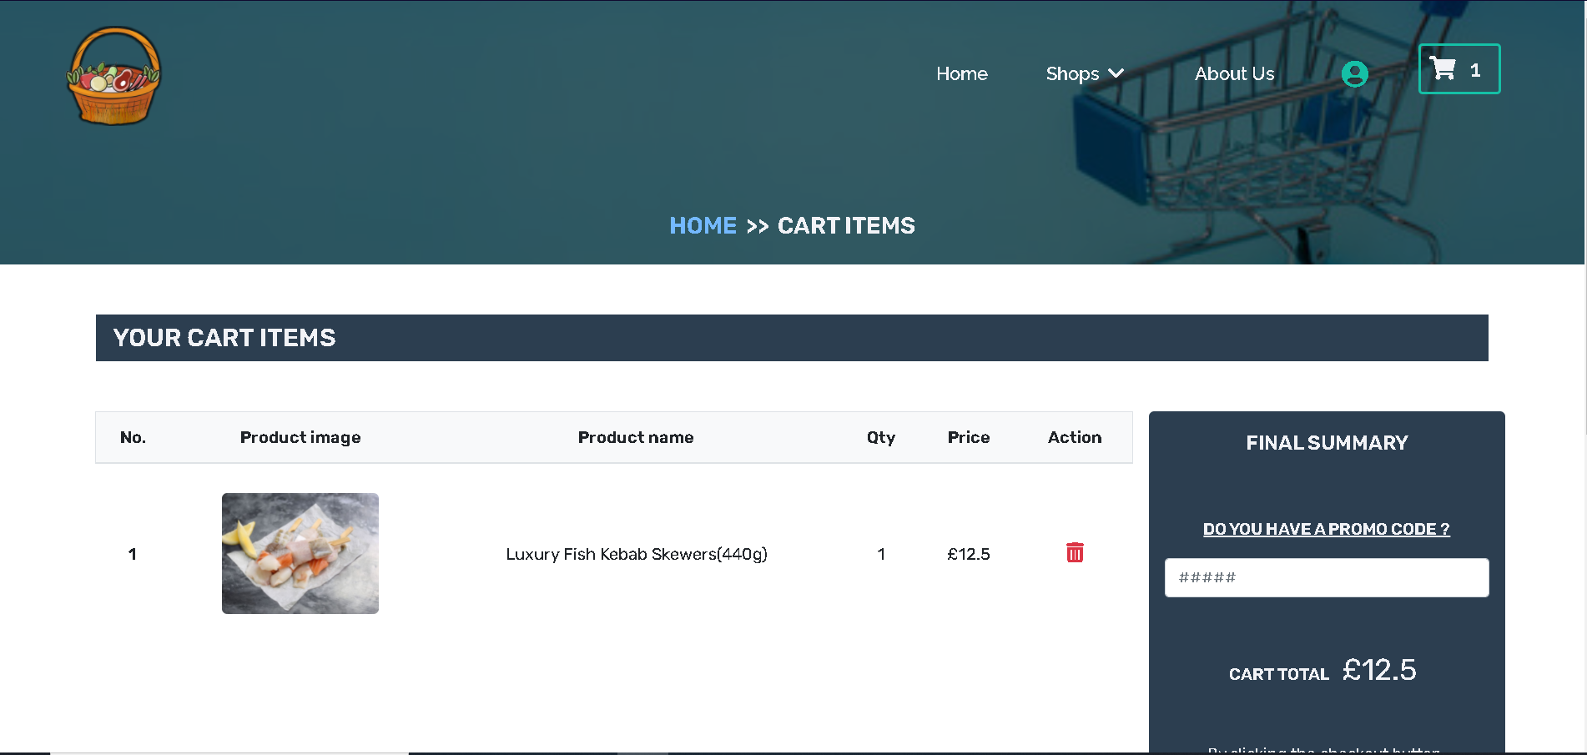

Proceed to checkout (Registered Customer)

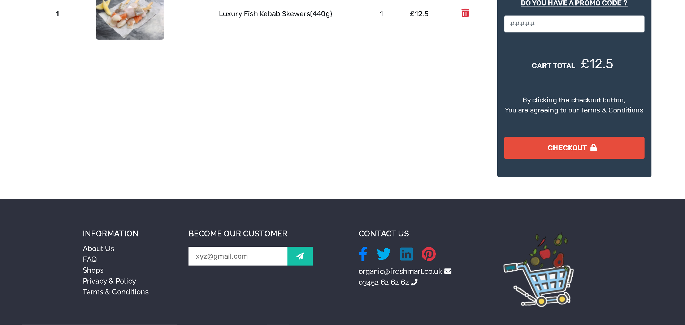

* Customer chooses collection slot and proceed to PayPal for payment and if selected slot is full, customer will be able to choose next slot

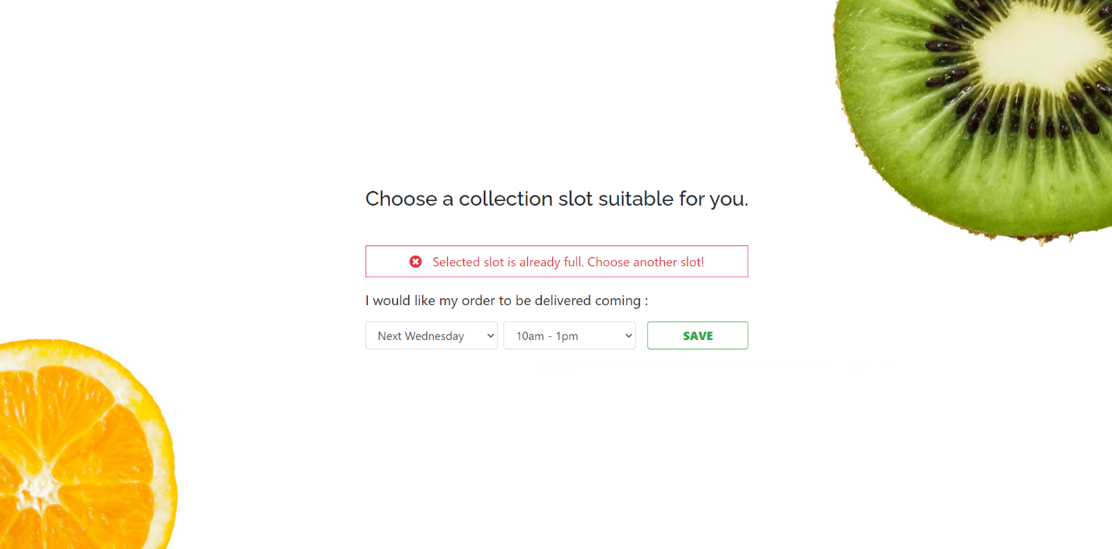

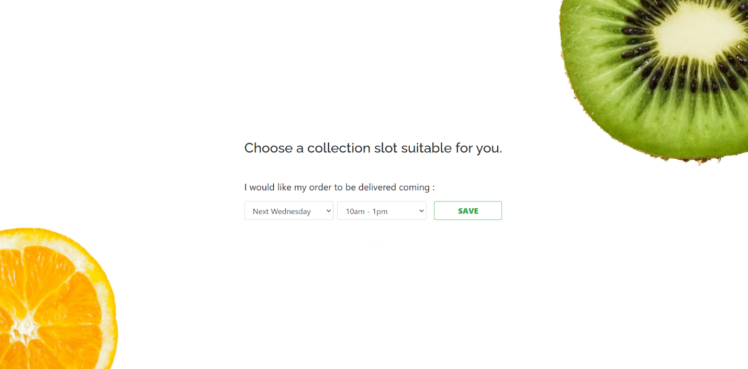

After saving the collection slot, PayPal payment option comes

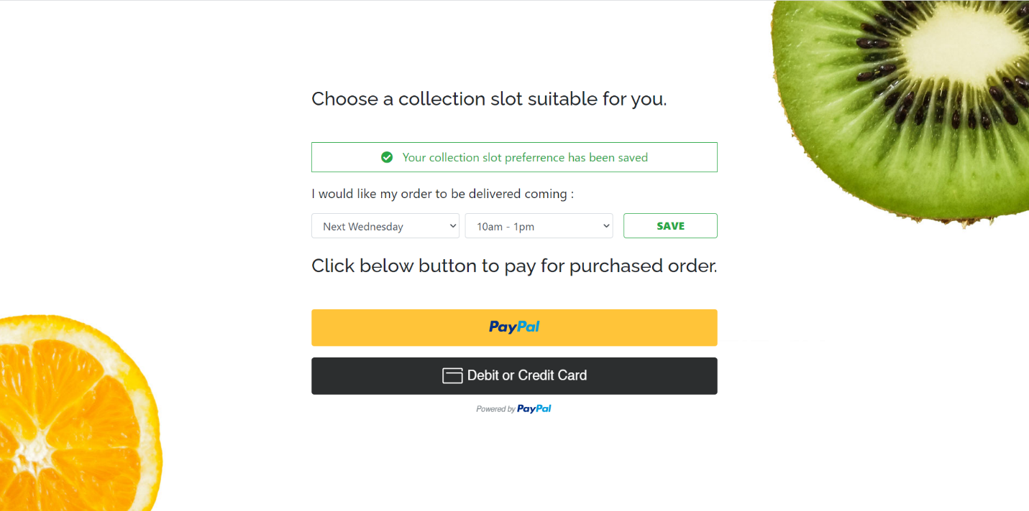

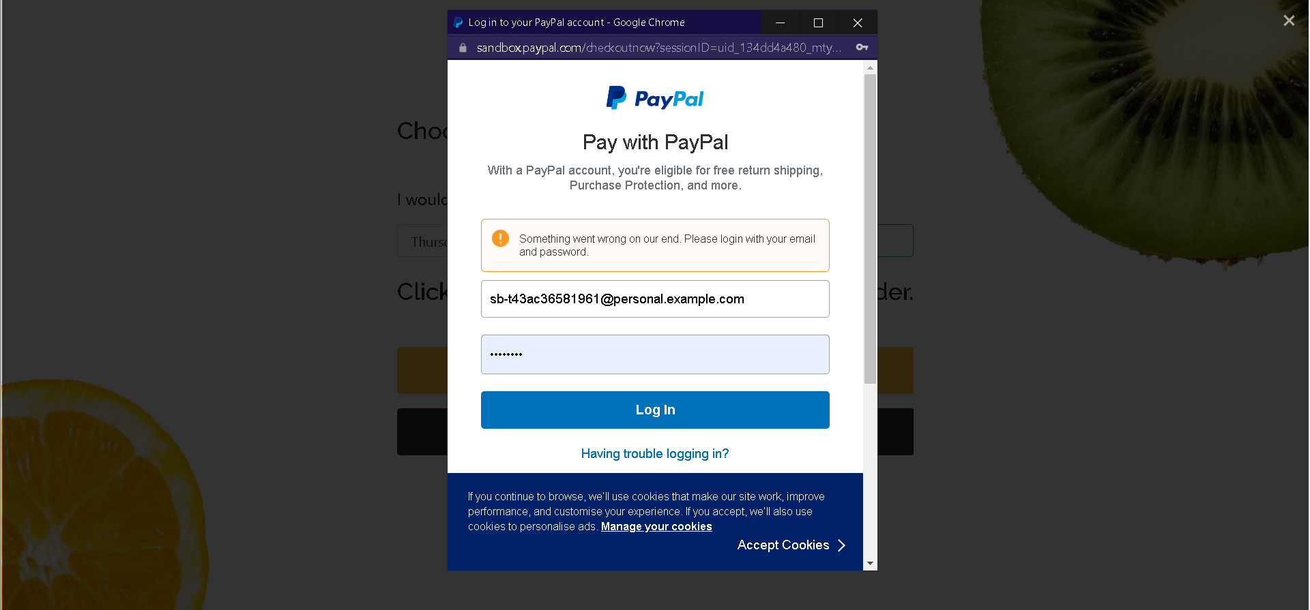

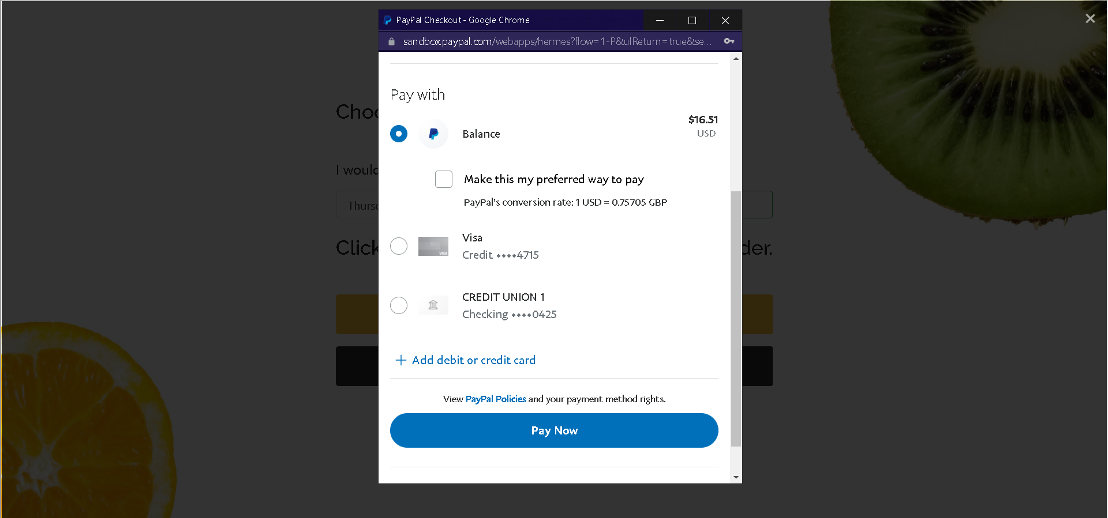

* Empty Cart

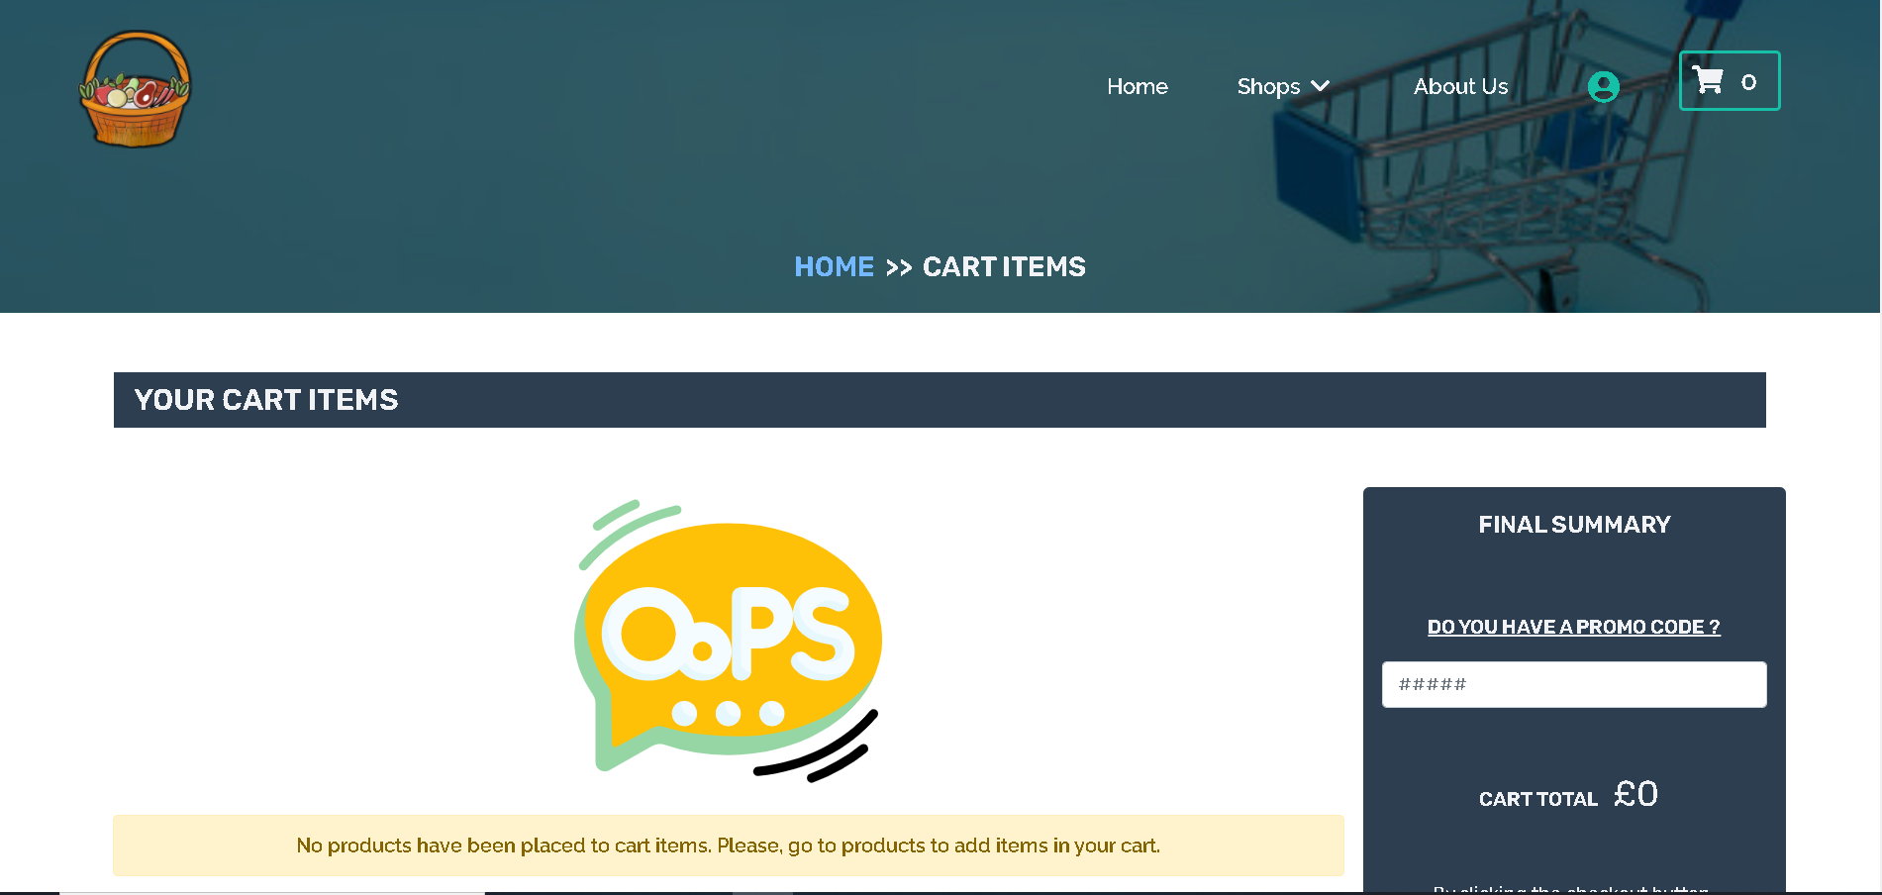

* After payment is successful, **Customer** is redirected to homepage and alert message is displayed and receipt is received in the mail

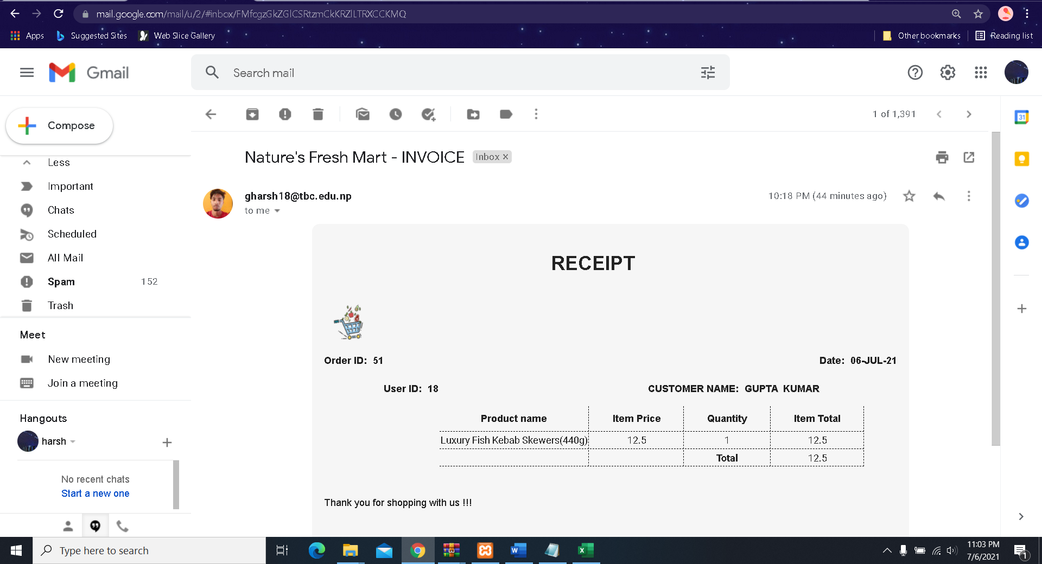

* Trader also receives invoice

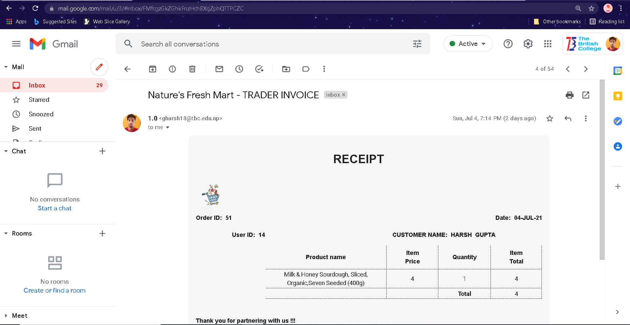

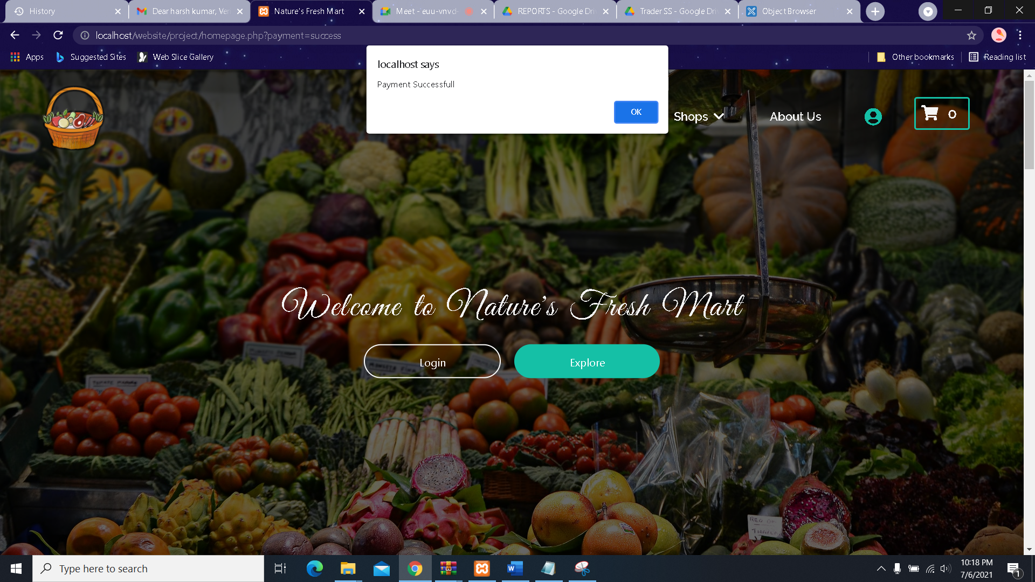

**FOR UNREGISTERED CUSTOMER**

They are able to access everything like view product, add to cart

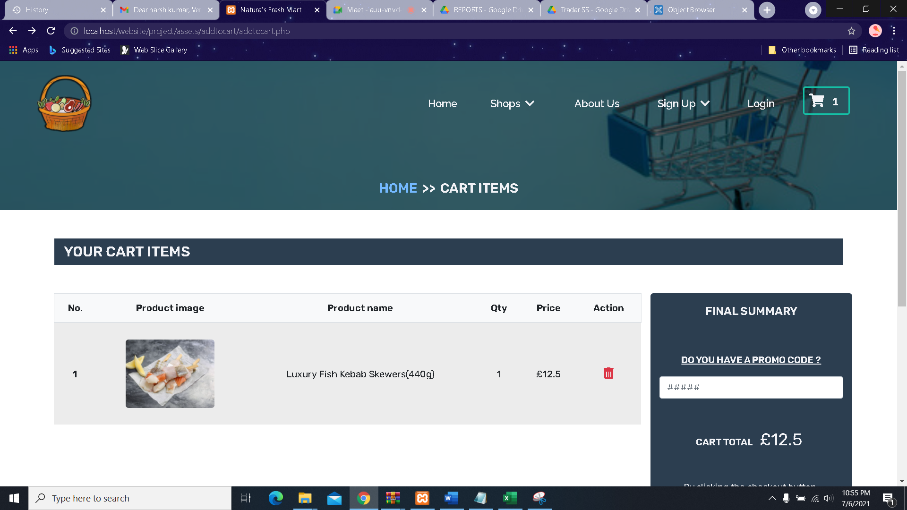

But after checkout is pressed, customer is directed to sign in page

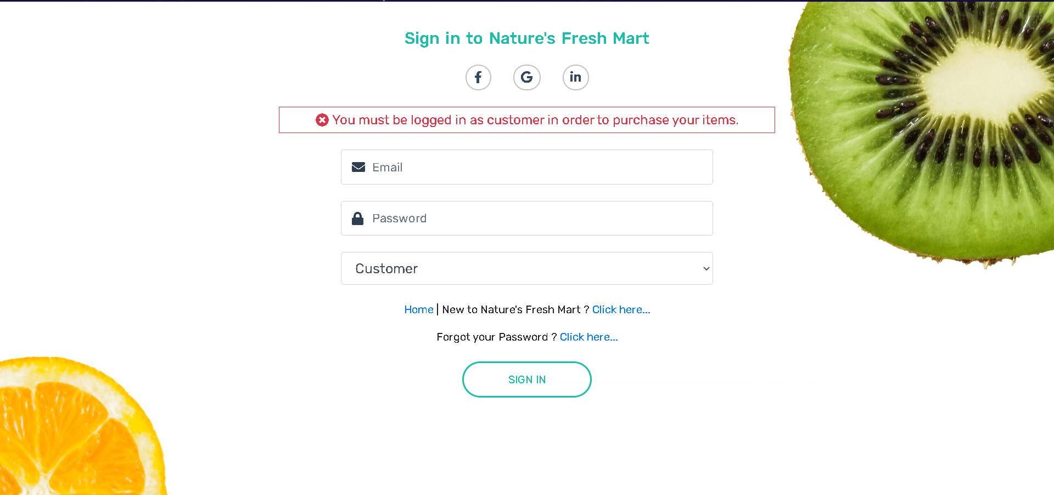

* After logging in customer can leave **Reviews** on any product.

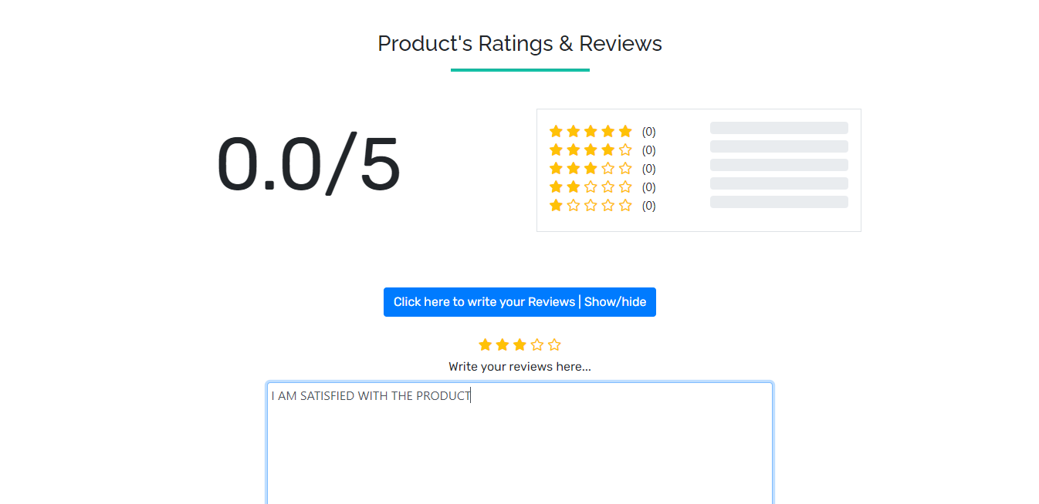

* Customer can now view their purchase history in the **Dashboard** inside customer panel

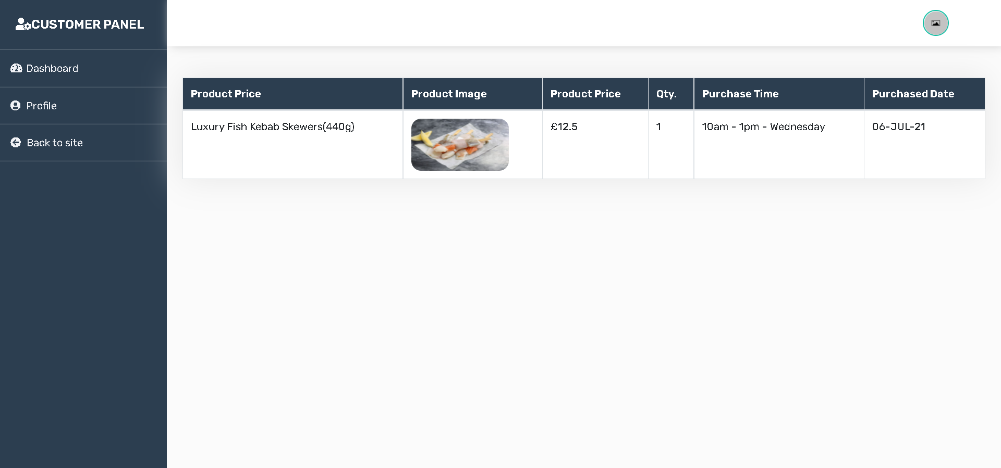

* After placing order, customer logs out of page and is directed to homepage

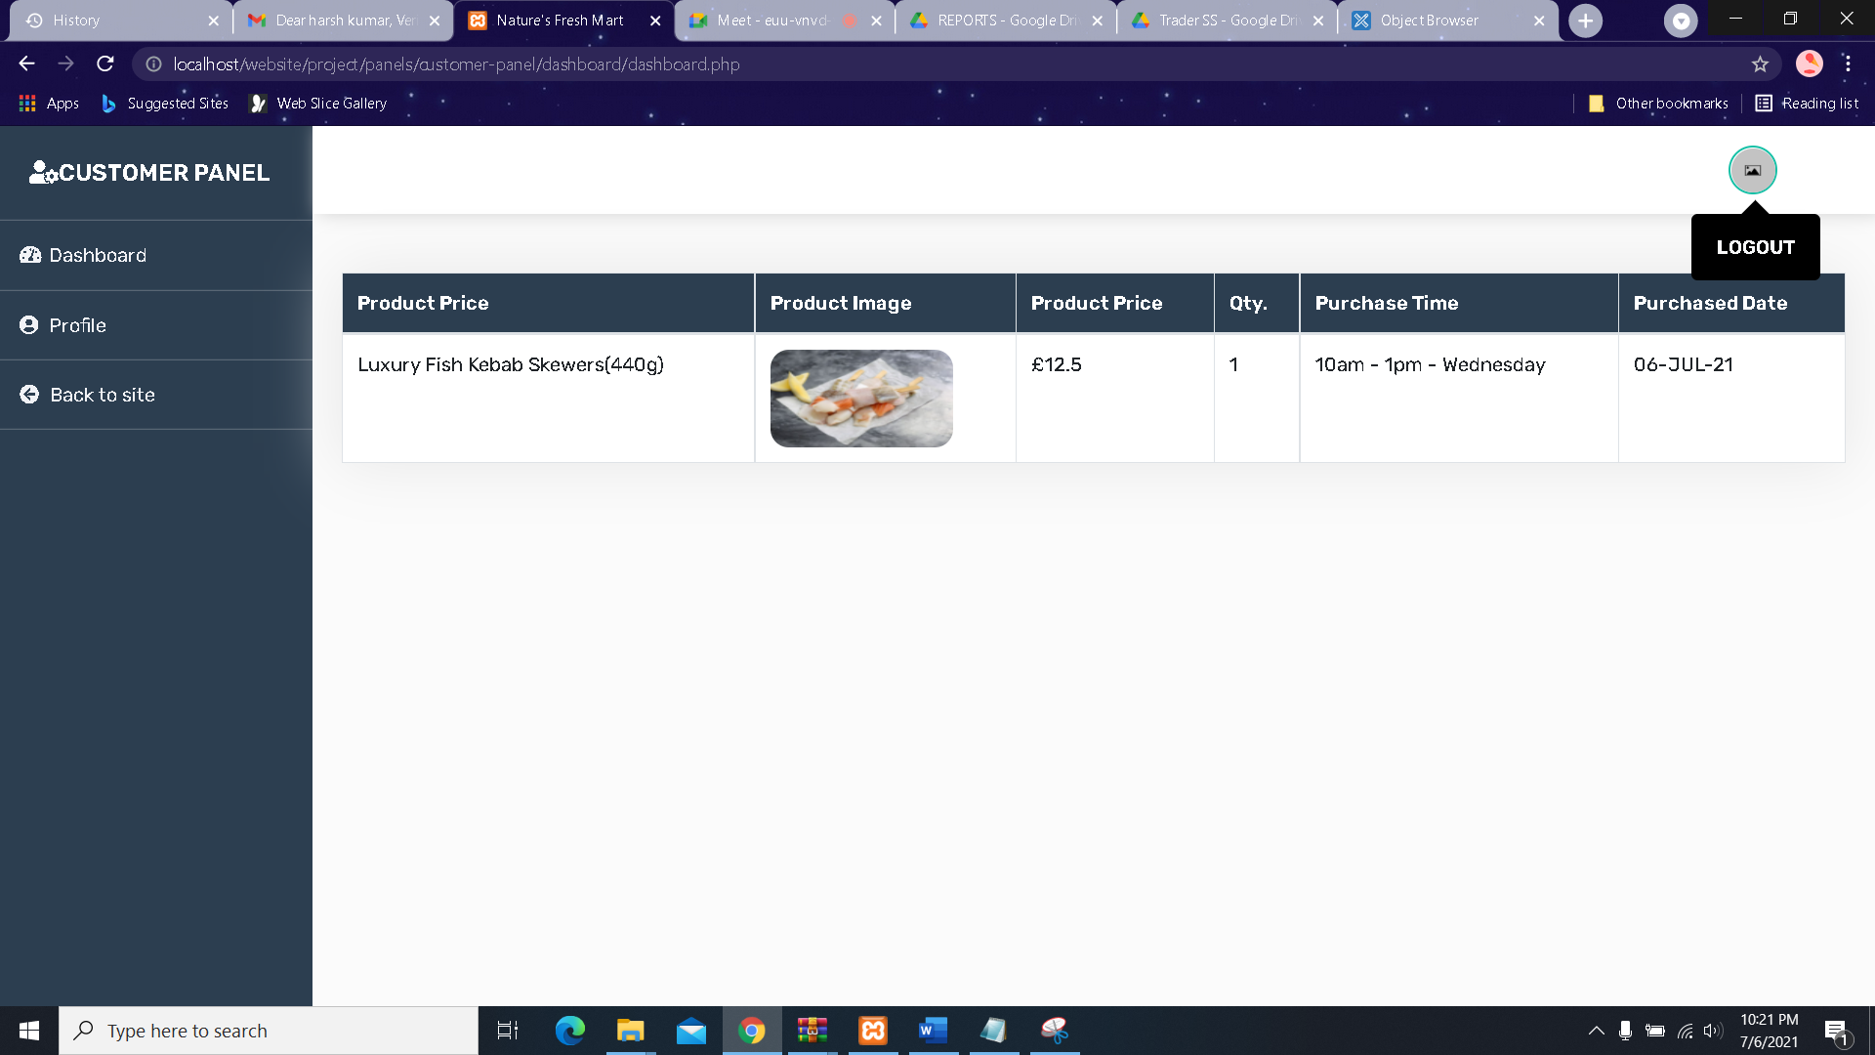

* Redirected to Homepage after logout

